KubeLantern: AI-Assisted Incident Diagnosis for Shared Kubernetes Platforms
Oct 9, 2026 · @rohit shalgar11
- Fixes live in people's heads, so every team relearns them

Why use KubeLantern
- Faster fixes: each incident arrives with the likely cause, the evidence and next steps
- Less load on the platform team: app teams fix their own issues without raising tickets
- Secure by design: a namespaced Role only, no ClusterRole, no access to Secrets, short-lived tokens
- Data stays in-house: can run a local AI model inside the cluster; Azure OpenAI and others are optional
- No licence cost: open source (Apache-2.0), so security can review the code and there's no vendor lock-in
- Shared knowledge: a runbook library (43 today) that the platform team updates without rebuilding anything
- Quiet upgrades: maintenance mode pauses incidents and alerts during cluster upgrades
- Fits our tooling: deploys with Helm or ArgoCD, sends alerts to Teams, Slack or email

Time saved in troubleshooting
Most of the time spent on an incident goes into finding the cause, not fixing it. KubeLantern does that groundwork automatically.
Step | Today | With KubeLantern
Noticing the failure | Someone spots it or a user reports it | Detected automatically, often before users notice
Collecting evidence | Engineer runs kubectl for pod status, events, logs and config | Gathered in one place within moments of the failure
Finding the cause | Depends on who is on shift and how experienced they are | Likely cause shown, matched against shared runbooks
Getting help | Ticket or chat to the platform team, then waiting | Next steps sent straight to the team's channel
Handing over | Context lost between shifts and teams | Same incident record for everyone, with all the evidence
- Shorter time to resolution (MTTR): engineers start with the cause instead of hunting for it.
- Works around the clock: diagnoses are ready for on-call engineers at night, without waking a platform expert.
- Less back-and-forth: incidents come with evidence attached, so there are no follow-up "send me the logs" requests.
- Junior engineers fix more themselves: runbook guidance turns expert know-how into steps anyone can follow.
- Repeat issues get faster: each recurring failure maps to a runbook, so the second fix is quicker than the first.
- Platform team gets time back: fewer triage requests means more time for upgrades and platform improvements.
- No wasted time during upgrades: maintenance mode stops false alarms, so nobody chases expected restarts.

How it works
An agent in each team's namespace detects failures, collects the evidence and gets a diagnosis from a central AI gateway. The gateway checks rules and runbooks before it asks the AI model.
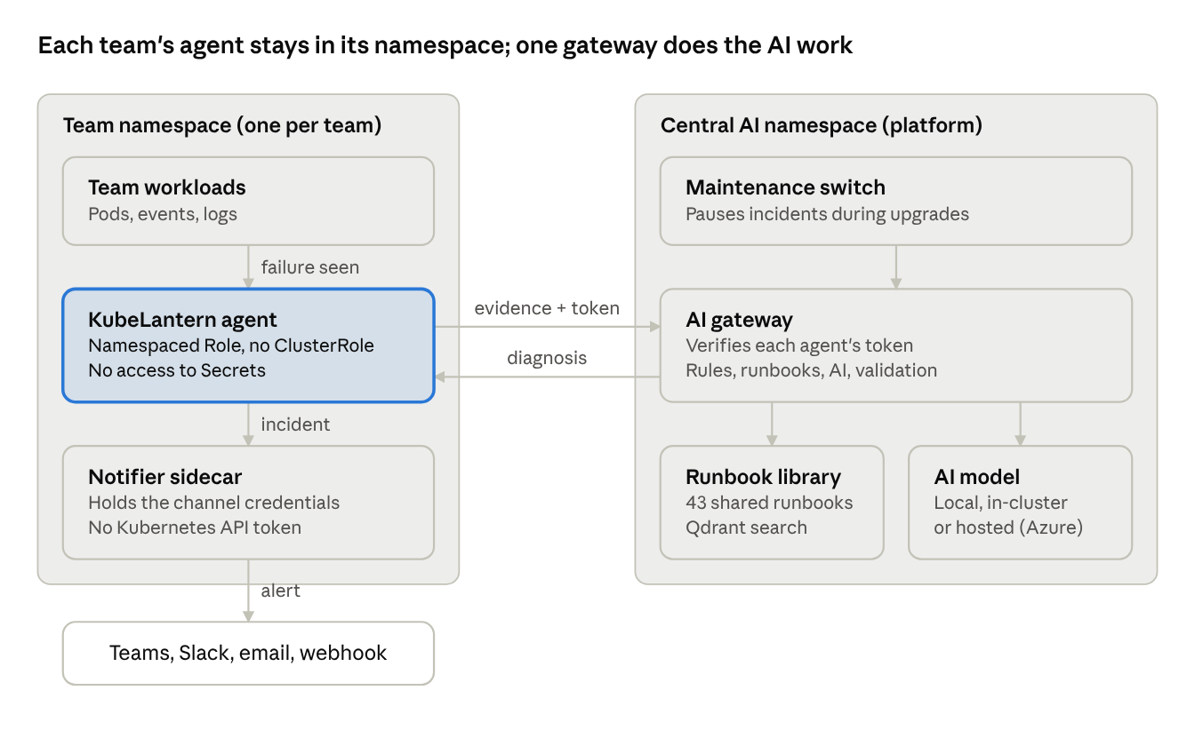
architecture · per-team agent and central gateway
Only evidence and the diagnosis cross the namespace boundary. Credentials for the AI model and for the notification channels each stay in one place.

Where to use it and rollout
It fits any shared, multi-team cluster: dev, UAT and production, including air-gapped clusters when it uses the local model. We start small and expand only after each gate is met.
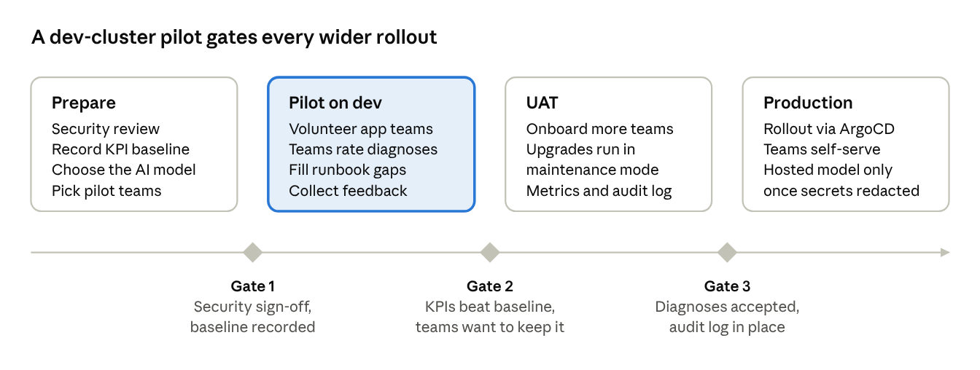
rollout plan · 4 phases, 3 gates
We measure success against a baseline: time to diagnosis, the number of platform tickets, and how often teams rate a diagnosis as correct.

The ask
- ☐ Approval to run a pilot on the dev cluster with a small group of volunteer application teams
- ☐ A decision on the AI model for the pilot: local in-cluster model or our Azure OpenAI tenant
- ☐ Security team review of the design and code before the pilot starts
- ☐ Platform-team time to deploy, support the pilot teams and report results
Source code and docs: https://github.com/rohitshalgar11/KubeLantern

